Library Science Collection Resources for Tech Training
The Texas State Library & Archives Commission maintains a working Library Science Collection of professional books, DVDs, and journals serving Texas librarians in all kinds of libraries. Most loans travel by mail, and the only cost to this service is the responsibility of return postage at the library mail rate.
The following titles provide information related to offering technology training for patrons and implementing technology solutions at your library. Contact lsc@tsl.state.tx.us to borrow these titles or inquire about other available resources for any topic related to library science, including free CE options.

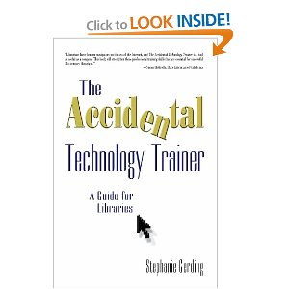

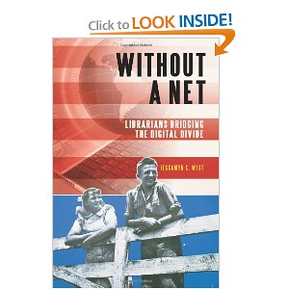

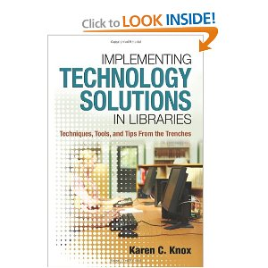

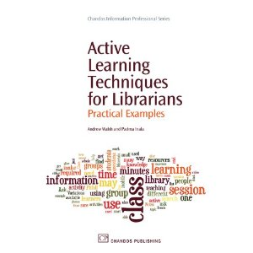

The Accidental Technology Trainer (2007) Author: Stephanie Gerding
Facilitation Basics (2004) Authors: Donald V. McCain and Deborah D. Tobey
Libraries Connect Communities (2009) Editor: Larra Clark
Digital Inclusion, Teens, and Your Library (2005) Author: Lesley S. J. Farmer
Bridging the Digital Divide in the Spanish Speaking Community, (2004) Library Video Network
Without A Net, Librarians Bridging the Digital Divide (2011) Author: Jessamyn C. West
Web 2.0 for Librarians and Information Professionals (2008) Author: Ellyssa Kroski
Implementing Technology Solutions in Libraries (2011) Author: Karen C. Knox
Technology Made Simple, An Improvement Guide for Small and Medium Libraries (2007) Authors: Kimberly Bolan and Robert Cullin
The Complete Library Technology Planner (2010) Authors: John M. Cohn and Ann L. Kelsey
Active Learning Techniques for Librarians (2010) Authors: Andrew Walsh and Padma Inala
101 Ways to Make Training Active (2005) AuthorMel Silberman
Competency Based Training Basics (2010) Authors: William J. Rothwell and James M. Graber
ASTD’s Ultimate Train the Trainer, A Complete Guide to Training Success (2009) Author: Elaine Biech
Slide:ology, The Art and Science of Creating Great Presentations (2008) Author Nancy Duarte

